**Topic:** Euclid, The Infinitude of Primes

**Notes on Topic:** Book II - VI:  
**insert Prop II.4** // Book II explored geometric algebra //

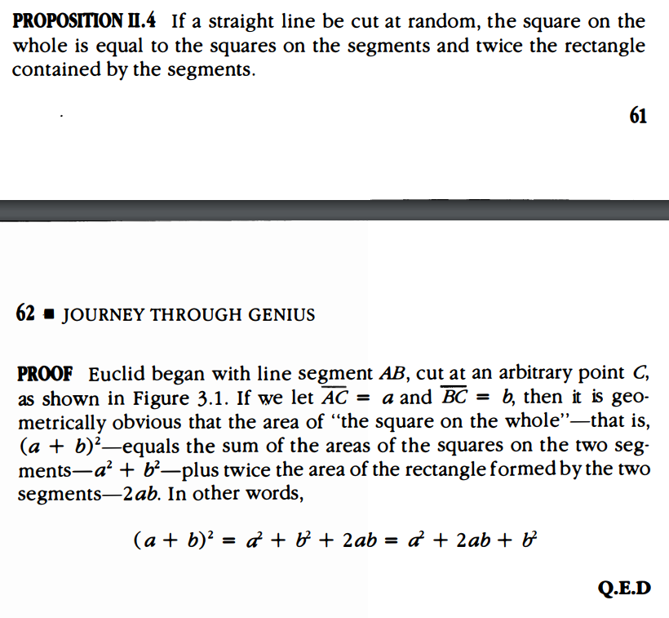

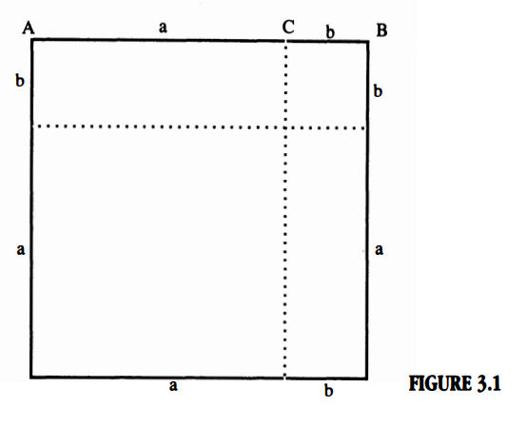

**insert Prop III.22** // Book III mostly explored circles //

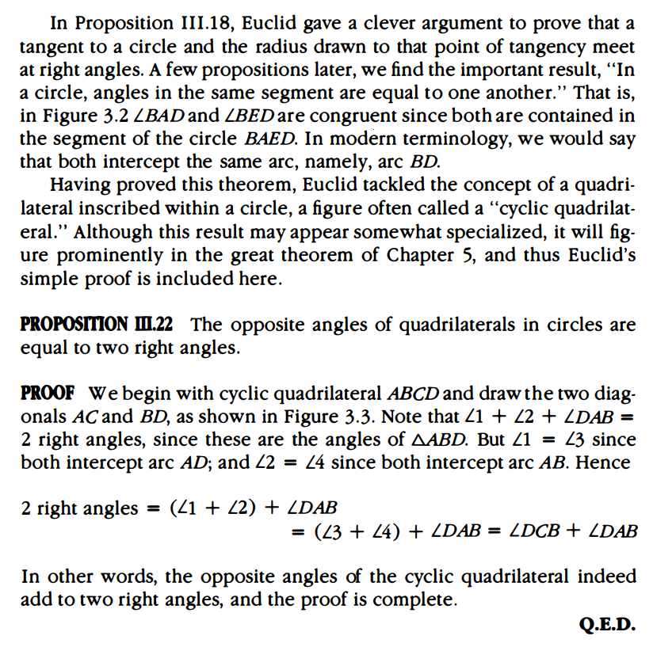

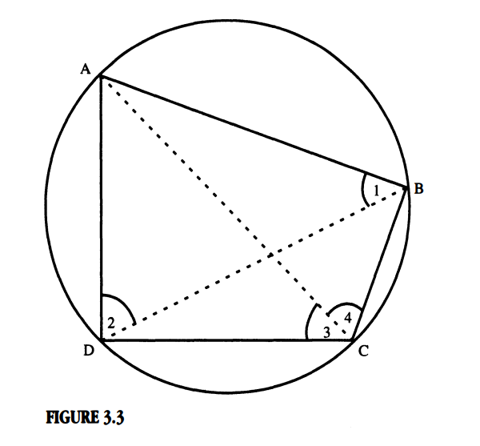

This was the proposition that led to proving Thales Theorem, angles inscribed in a semi-circle are right angles

// Book IV dealt with inscribing and circumscribing figures //

Prop IV.4 showed how to inscribe a circle into a triangle by making the center of the circle the point where all the vertex angle bisectors meet and then Prop IV.5 showed how to circumscribe a circle about a triangle by making the center of the circle the intersection of the perpendicular bisectors of the triangle sides  
Euclid then went on to constructing “perfect” polygons, whose sides and angles are all of equal measure  
Prop IV.11 Euclid inscribed a pentagon in a circle  
Prop IV.15 inscribed a hexagon in a circle  
The final construction, is a regular 15 sided polygon inscribed in a circle

**Activity: look at Euclid’s construction of the 15 sided polygon**

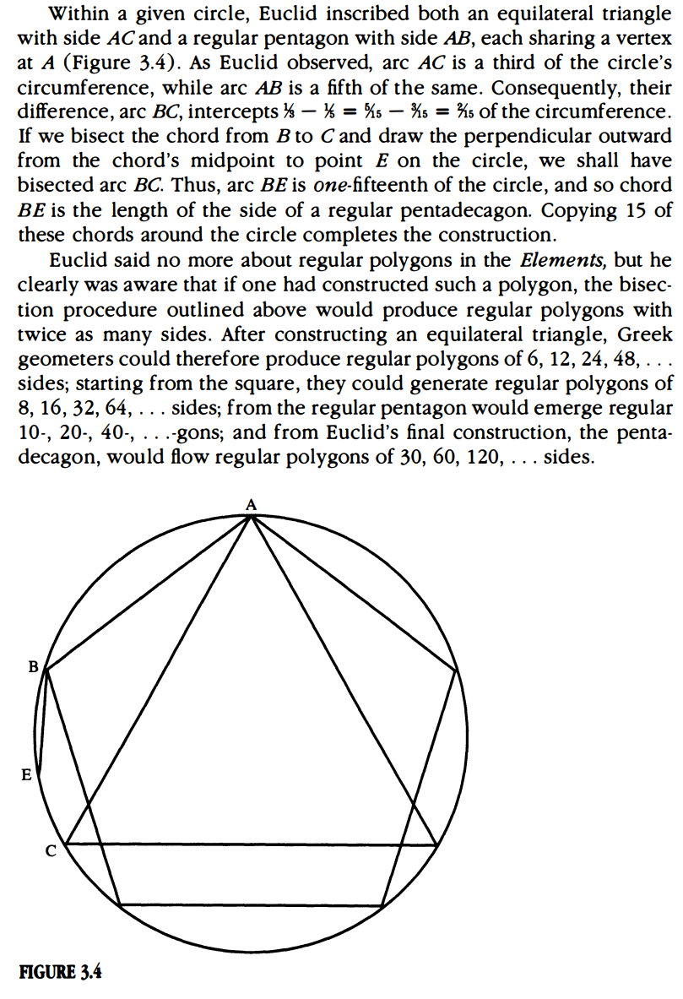

Nowhere does Euclid mention constructing a 7-, 9-, or 17-gon, since it did not fit the convenient doubling method  
 It was shocking when Carl Friedrich Gauss constructed the regular 17-gon in 1796, this left his mark as a mathematical genius  
  
Book V was reserved for continuing Eudoxus’ ideas, proving to be so profound as to influence thinking even in the nineteenth century about irrational numbers  
  
Book VI:  
Book VI dealt with similar plane figures in plane geometry   
Def VI.1: Similar rectilineal figures are such as have their angles severally equal and the sides about the equal angles proportional

This definition makes it clear, that the requirements for being similar are both equal angle measures and proportional side lengths

The strict requirement is lifted, though, for triangles. In Book V, in V.4, the Eudoxus theory states that if two triangles have their corresponding angles equal, their sides are proportional, and he proved the converse in V.5, that if two triangles have their sides proportional, their corresponding angles must be equal. To sum, in the matter of triangles, proving similarities is simpler, because one implication implies the other. So suffice it to say that two triangles having corresponding angles equal OR having proportional sides will prove similarity.

Thus triangles are used time and time over to show other polygon similarity.

**insert Prop VI.8 and proof**

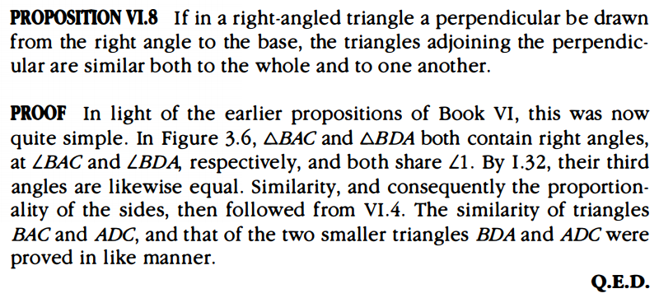

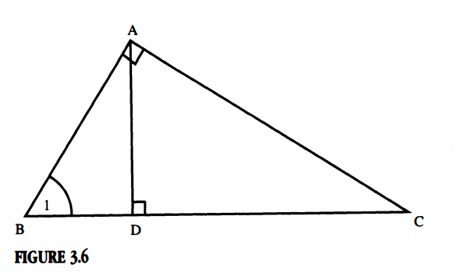  
  
With the thirty-third propositions summed up, thus ends the development of Euclid’s plane geometry. The next section had proven to be a gold mine for mathematicians through the years  
  
**Number Theory in Euclid:**Book VII begins with 22 new definitions involving the whole number  
Even, odd, prime, composite, perfect number (a number that is the sum of its “parts” meaning its proper divisors)  
Euclid starts with the renown, Euclidean Algorithm, an algorithm for finding the greatest common divisor of any two given number  
**insert euclidean algorithm example here** // Any example will do, perhaps have the students shout out two numbers

Prop VII.30: if p, prime, p|ab, then p|a or p|b

**insert Prop VII.31 and proof** the proof remains identical to that found in modern day number theory

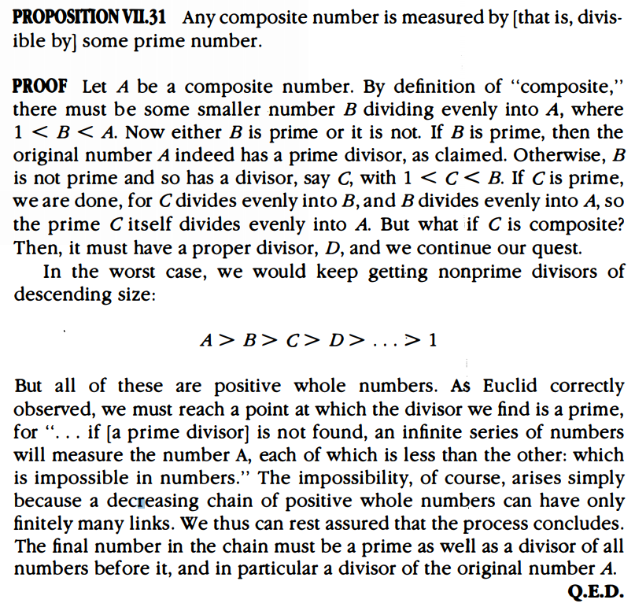

Book VII, VIII, and IX flow into one another seamlessly, leaving one to wonder why they are divided into three different books, but nevertheless.  
All books lead to the all important Prop IX.14: fundamental theorem of arithmetic, any number can be factored into a unique factorization of primes  
**include example: suppose we have many powers of 8 and want to know how many powers do we need to get a number that ends in 0? Suppose N is the number that ends in 0, composed of powers of 8, if we write the prime factorization of N, since it is powers of 8, it will be a long string of 2 since 8 = 2*2*2. Thus is N ends in 0, then it is divisible by 10, and therefore would necessarily be divisible by 5, but this is contradictory since N is just a string of 2’s. **

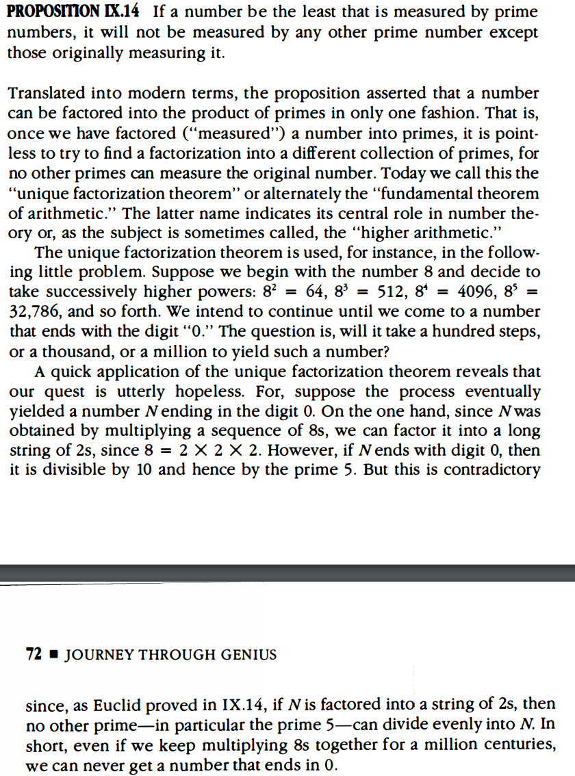

Mathematicians would write out the first few primes looking for patterns, but the patterns they could come up with did not give insight into being able to predict what the next prime is. They realized that they are all odd and as the numbers get larger, the primes get scarcer.  
It led Greek mathematicians to believe that the primes would grow so scarce as to completely disappear.   
Euclid was not swayed, his Proposition IX.20: the infinitude of primes, which leads us to our next great theorem

**Additional Suggested Reading**: Book II - IX, *Elements*

**Assignment:** Homework Problem 36, 37, 43, 45, 47,